Requirements Document
Project Name: STEM
Name: Martin Reyes

1) Project Definition:

Android application that will serve as a learning tool for the end user.

2) Purpose:

The purpose of the program is to help the user develop their knowledge on STEM subjects.

3) The user environment:

Who will be the users of the system?
-Any individual can be an end user
-Intended audience is children ages pre-kindergarten to college age
What level of education or training do the users have?
-The user will require little to no education as the system will provide that.
What computer skills do the users have?
-The user will require relatively simple knowledge of how to use a smart phone.
Are users familiar with this type of IT system?
-Most users in this day in age are very familiar with the system.
What technical platforms do they use today?
What are your expectations regarding system usability?
-The expectation for the system usability is high because most people use smart phones.

4) Scope:

-Android application
-Study mode
-Play mode
-Art resources for the play mode
-Content for the study mode

5) Functionality:

-Start screen will have the option to go into the study mode or play mode
-When in play mode there will be a toggle button to switch to study mode
-When in study mode there will be a toggle button to switch to play mode
-There will be different study options too
-Reading about a subject
-Answering multiple choice question
-Doing an interactive activity
-There will be one type of play mode
-There will be a point system that can be used in the game mode for upgrades
-The system will keep track of the points based on the activities completed
-Users will be able to still get points even if they redo the same activity
-Any re-done activities within a week time will get reduced points
-After one week that same activity will go back to regular points

6) Use Cases:
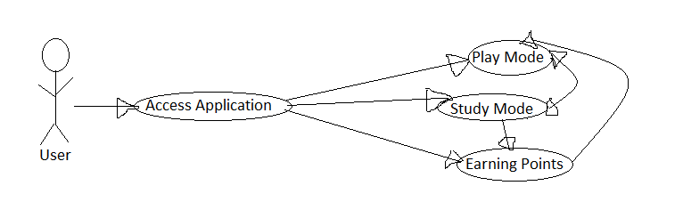

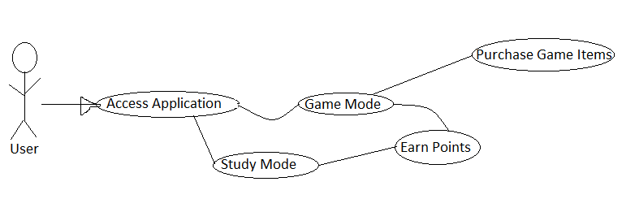

UC 3:
1. User accesses application
2. User selects game mode
3. User uses the touch screen to interact with the game environment
4. The game environment reacts to the user’s touch commands
5. User exits the application
6. User reopens the application and resumes where they left off on

UC 4:
1. User accesses application
2. User selects study mode
3. User uses the touch screen to interact with the study mode environment
4. User exits the application
5. User reopens the application and resumes where they left off on

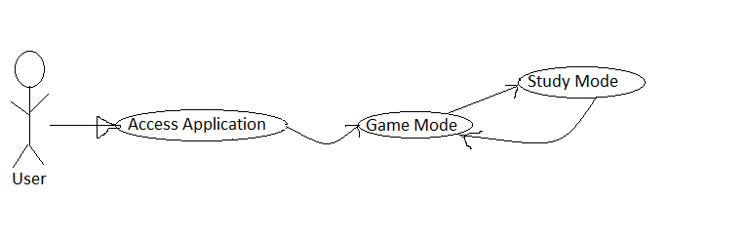

UC 6:
1. User accesses application
2. User selects play mode
3. User performs tasks in play mode and earns points/currency
4. User exits the application
5. User reopens application and checks that the points are still there

UC 7:
1. User accesses application
2. User selects play mode
3. User performs tasks in play mode and earns points/currency
4. User performs the same task within a week of the previous attempt and earns less points
the previous attempt.
5. After a week of the first attempt, the points earned reset
6. User attempts task after a week and earns the same points from the attempt from a week ago

UC 8:
1. User performs task and earns points
2. User does another task and more points get added to the points earned

